Supplementary Information
Utilization of Cartilage Sheets for Localized Tracheal Defect Repair in a Goat Model
Ming Deng^{1, §}, Chao Wang^{1, §}, Yong Xu^{1,} *, Gening Jiang^{1,} *
¹ Department of Thoracic Surgery, Shanghai Pulmonary Hospital, Tongji University School of Medicine, 200433 Shanghai, China
§These authors contributed equally.
*Corresponding authors. E-mail address: Dr. Yong Xu (xuyong@tongji.edu.cn); Prof. Gening Jiang (geningjiang@tongji.edu.cn).

Supplementary Methods
1. Materials
Young's modulus was tested and analyzed in accordance with our previously reported methods [17]. Briefly, all samples were determined using a biomechanical analyzer (Instron-5542, Canton, USA) with a constant crosshead speed of 1 mm/min. The samples, which included in vitro-cultivated cartilage sheets (2, 4, 8 weeks), in vivo-cultivated stacked sheets (4, 8 weeks), and native tracheal cartilage (n=3 per group), were subjected to unconfined compression up to 80% of their maximal deformation. The modulus was calculated from the slope of the resulting stress-strain curve.
2. T-tube
The design and manufacture of the T - tube referred to the Montgomery T - tube. The T - tube has a T - shaped three - way structure, consisting of a main limb that is vertically inserted into the trachea and a lateral limb that horizontally passes through the tracheostomy. Both ends of the main limb are designed in a conical shape, which can reduce damage to the tracheal mucosa. The end of the lateral limb can control the ventilation path through a sealing plug. Its material is medical - grade silicone, with no surface coating design.

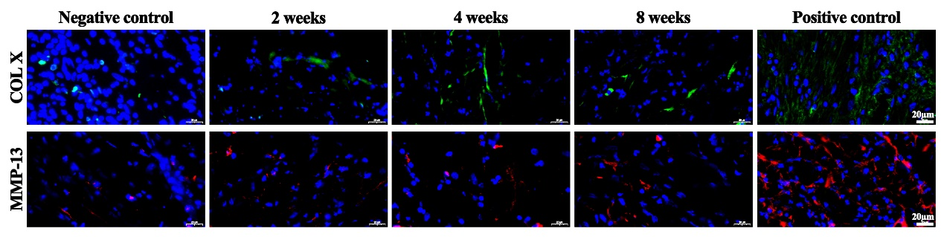
Fig 1. Representative immunofluorescence images of COL X and MMP-13 in in vitro-cultivated cartilage sheets at weeks 2, 4, and 8. Images include positive and negative controls.

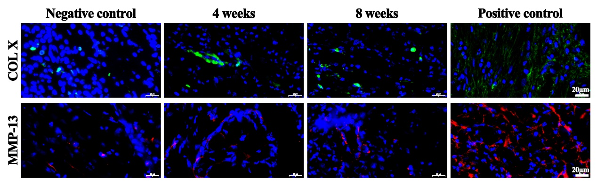
Fig 2. Representative immunofluorescence images of COL X and MMP-13 in engineered cartilage sheets following in vivo implantation. Samples were harvested and analyzed at weeks 4 and 8, with positive and negative controls included.

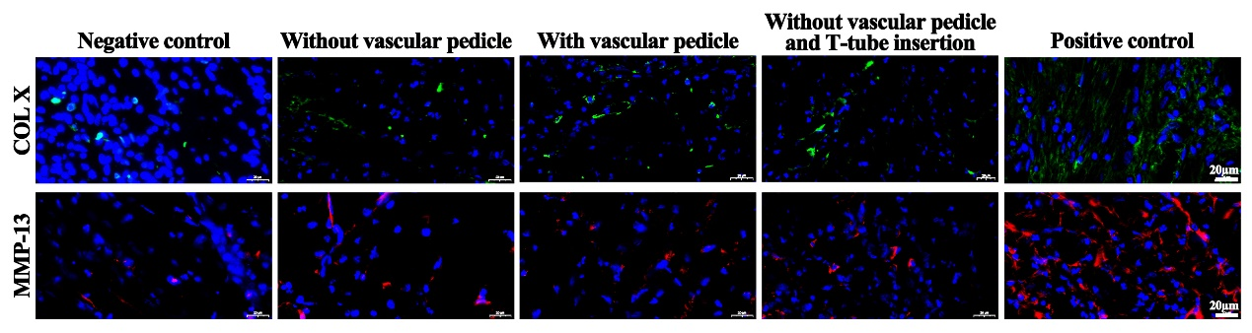
Fig 3. Comparison of COL X and MMP-13 expression by immunofluorescence in tracheal repair models using stacked cartilage sheets under different surgical conditions. The experimental groups include: no vascular pedicle, preserved vascular pedicle, and no vascular pedicle with T-tube insertion. Images include positive and negative controls.

